**Test Plan**

|  |  |
| --- | --- |
| No | Action |
| 1 | Enter give us 100 marks when Enter commands. |
| 2 | Create a member which is belong Happy Corporation (hc). |
| 3 | Change the member company toGrantFitness Corporation (gf) and the id is 2222, name is Ricky Wong, phone is 91238765, hour is abc. |
| 4 | Change the hour to 10. |
| 5 | Create a member which is belong GoodHealth Fitness Corporation (gh) and the id is 1111, name is Kayee Liu, phone is 67892345, hour is 300. |
| 6 | Check member which id is 0000 details. |
| 7 | Check Ricky Wong's details. |
| 8 | Check All members' details. |
| 9 | Add * hours to Kayee Liu. |
| 10 | Add -10 hours to Kayee Liu. |
| 11 | Add 1000 hours to Kayee Liu. |
| 12 | Check Kayee Liu's details. |
| 13 | Deduct b hours to Ricky Wong. |
| 14 | Deduct -100 hours to Ricky Wong. |
| 15 | Deduct 100 hours to Ricky Wong. |
| 16 | Deduct 1 hour to Ricky Wong. |
| 17 | Check Ricky Wong's details. |
| 18 | Enter more details when change the phone number to Kayee Liu. |
| 19 | Change the phone number 23382338 to Kayee Liu. |
| 20 | Check Kayee Liu's details. |
| 21 | Redo last command. |
| 22 | Undo last command. |
| 23 | Show the undo/redo list. |
| 24 | Redo last command. |
| 25 | Leave the system. |

**Test Case**

No 1.

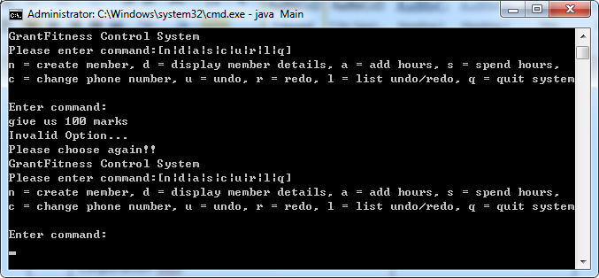

No 2.

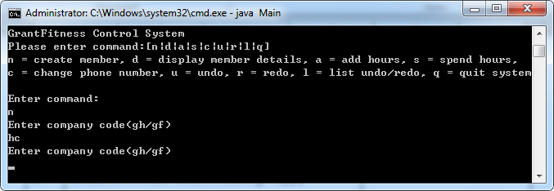

No 3.

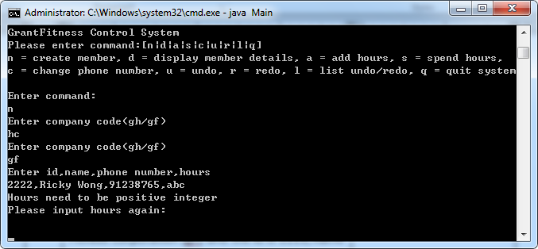

No 4.

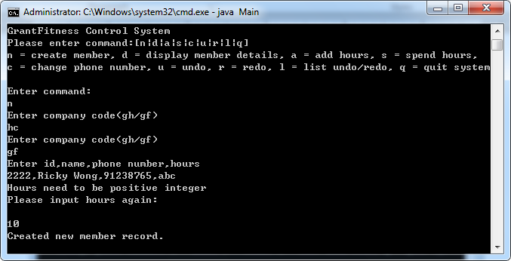

No 5.

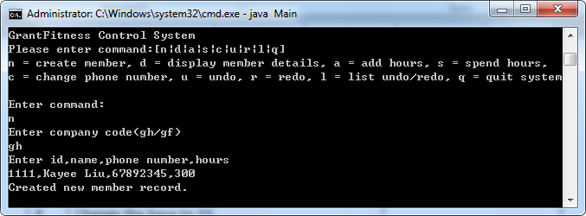

No 6.

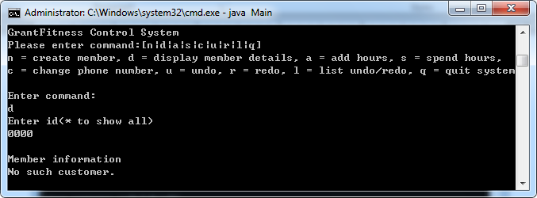

No 7.

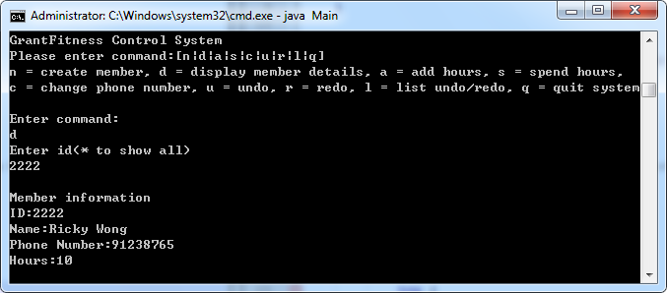

No 8.

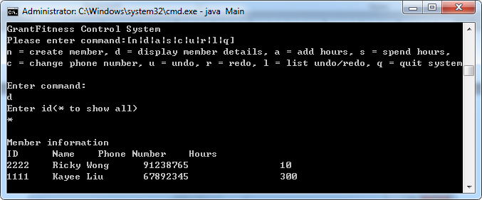

No 9.

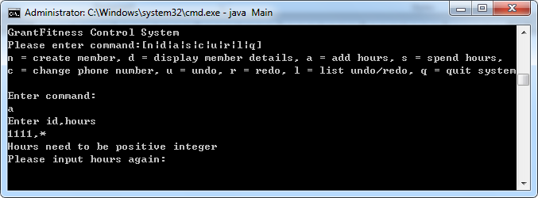

No 10.

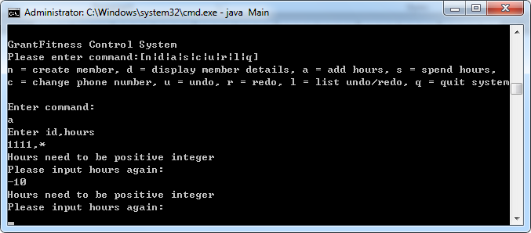

No 11.

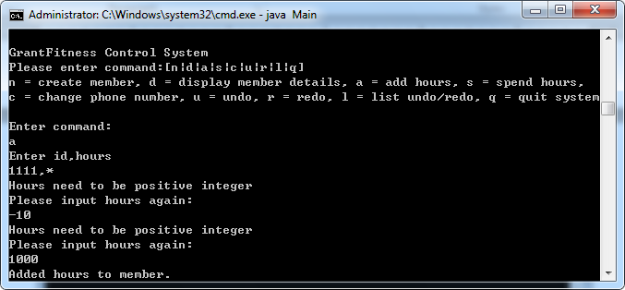

No 12.

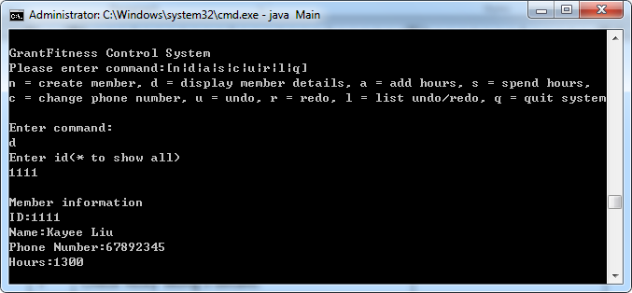

No 13.

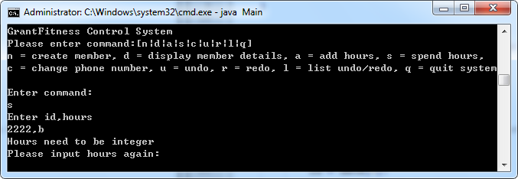

No 14.

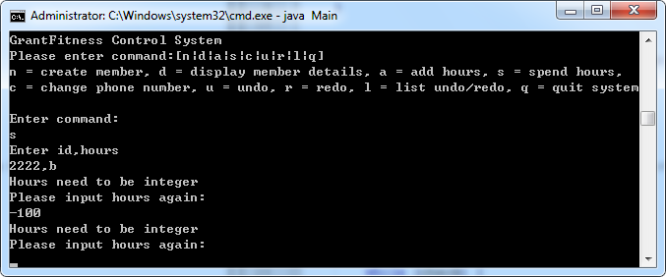

No 15.

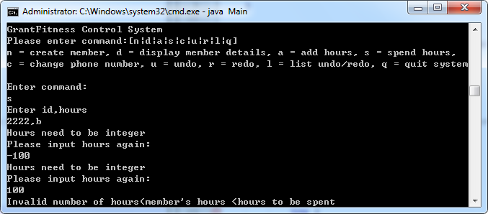

No 16.

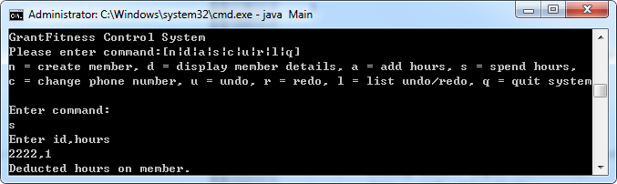

No 17.

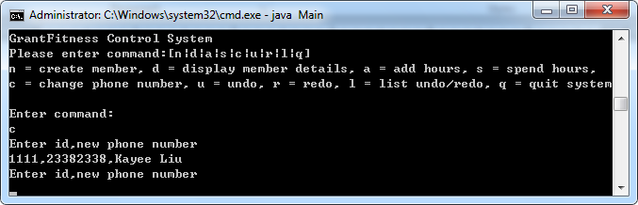

No 18.

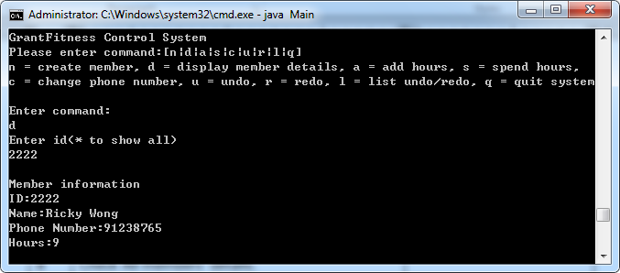

No 19.

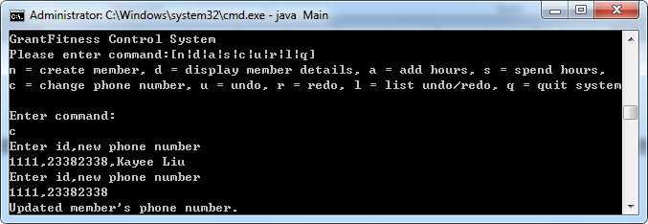

No 20.

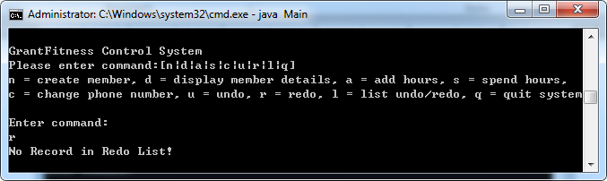

No 21.

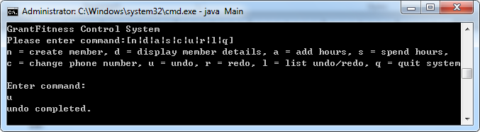

No 22.

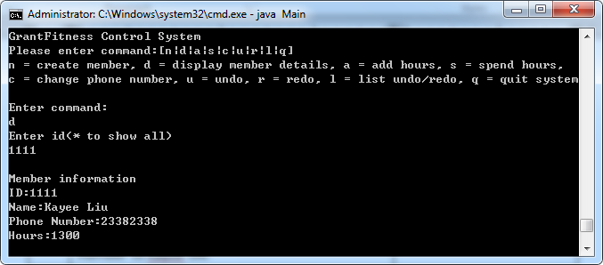

No 23.

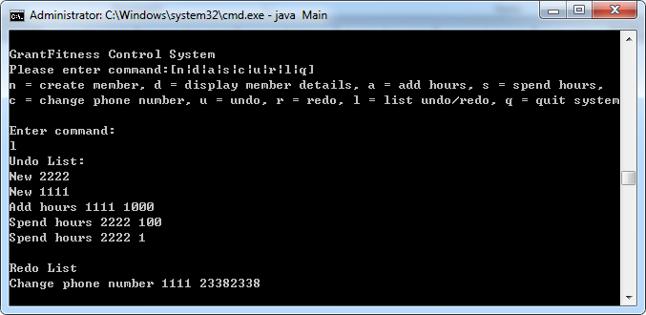

No 24.

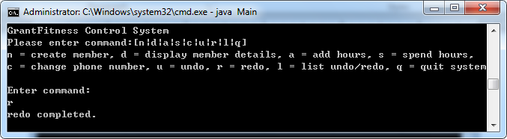

No 25.